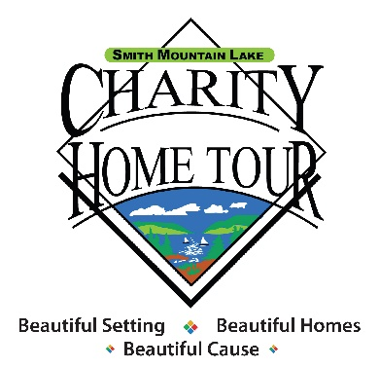

Smith Mountain Lake Charity Home Tour Fact Sheet

- The Smith Mountain Lake Charity Home Tour was founded in 1991 by community resident Jeanne Wagoner and her late husband, Joe Wagoner. In 1997 it was incorporated as the Smith Mountain Lake Home Tour, a 501(c) (3) non-profit corporation. The tour is the region’s community fund drive to support critical services for those in need in the lake region. We accomplish this through partnerships with volunteers, charities, homeowners, businesses and individuals.

- For 32 years, our mission has always been to raise funds to support local and charities through a united, volunteer-driven community effort.

- Nearly $4 million has been distributed to over 45 charities throughout the Smith Mountain Lake region since 1991.

- Last year over 2,150 people visited the homes on the SML Charity Tour making this tour one of the largest home tours of its kind in the country. It is the only home tour that can be reached by land and water.

- The Home Tour selects eight charities each year to receive all proceeds. Each charity is required to participate in fundraising and the staffing of one of the eight homes during the Tour weekend.

- More than 1,000 volunteers are involved in the Tour in the areas of home administration, fund raising, publicity, traffic control, tickets and technology. The Tour has no paid staff and 100% of sponsor dollars are distributed. Ticket sales cover expenses with the excess also distributed to the charities.

- Your support is so very appreciated!

DRB 5-12-23

