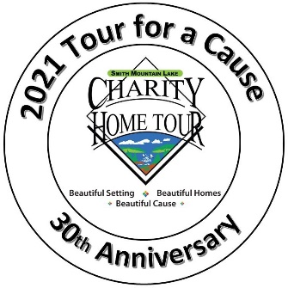 | SML Charity Home Tour 30th Anniversary  Business Sponsor Contract  This form is for LLC, Inc., or Sole Proprietorships  Mail to SML CHT, P.O. Box 416, Moneta, VA 24121  Or email cht2015@gmail.com | 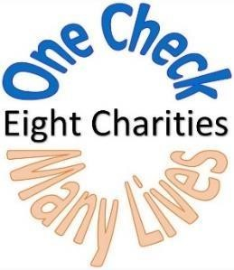
PLEASE PRINT LEGIBLY OR TYPE

Solicitor Name: _____________________________________________________________ Charity: __________________________________________________

Sponsor Name for Promotional Materials: ________________________________________________________Same ad as 2019/2020: Yes or No

Sponsor Web Site: __________________________________________________________________________________________________________________________

Marketing/PR Contact: _____________________________________Phone#:________________Email:_______________________________________________

Financial Contact: ___________________________________________Phone#: ________________Email:______________________________________________ (Invoices, receipts, and IRS letters will be sent via Email)

Mailing Address: ____________________________________________________________________________________________________________________________

Please select Sponsor Level (circle one)
Bronze $ 250
Bronze Plus $ 250 ($250 plus $250 each additional home you would like to sponsor)
Silver | $ 1,000
Silver Plus | $ 1,000 ($1,000 plus $500 each additional home you would like to sponsor)
Gold | $ 3,000
Diamond | $ 5,000
Premier | $10,000
Other | Please designate

Total Amount Contributed: $___________________Check if Rest Stop____

Payment Information: (check one)
_____Check Enclosed _______Please Send Invoice _______Credit Card (www.smlcharityhometour.com and click on “Donate Now.”)

Designate choice of homes based on sponsor level:
1.__________________________________2._________________________________3.___________________________________

Complimentary Tickets: You will receive one ticket for every $500 donated.

Terms
- This is a binding contract. It cannot be cancelled once it is processed.
- Sponsors must provide complete information on page 1 prior to this contract being processed.
- To be included in certain promotions, sponsor must have made full payment or be current with their payment plan.
- Sponsor is responsible for providing a digital copy of their logo and ad.

Name (print) ________________________________________________Signature___________________________________________________Date:_____________ I have read and agree to the terms listed above.

Page 2

Rest Stop Guideline: Rest stops require a minimum sponsorship level of Bronze. All rest stops must provide bathrooms for Tour guests. Tour will provide signs at your location and information in the Tour Guide.

Check One: _______ Full-service restaurant _______ To Go Food _______ Beverage and Bathroom

Media Deadlines

If Premier, Diamond, or Gold sponsor level, submit a PDF of your logo as soon as possible after signing a contract with the SML Charity Home Tour. These logos will be used on promotional materials, such as the 2021 Tour poster, rack cards, tickets (Diamond and above only), official Tour Guide, on the Smith Mountain Lake Charity Home Tour Facebook page, and on the Home Tour website (www.smlcharityhometour.com).

Ads will run in Laker Weekly, Laker Magazine, The Roanoke Times and Franklin News Post to promote the Tour. The first ad is scheduled for the Laker Weekly Memorial Day issue, hence the April 15th deadline for submitting Gold and above sponsor logos.

- Premier, Diamond and Gold deadline for submitting logo is June 15th, 2021, for use on all Home Tour ads and promotional materials.
- All sponsors who sign up and/or submit logos after June 15th, 2021, will be included in subsequent Home Tour ads and other promotional materials as print deadlines allow.
- Sponsors should e-mail logos and ad questions to smlcharityhometoursponsor@gmail.com.

Charity Home Tour Guide (Ad deadline July 15th, 2021. Email camera ready ad to smlcharityhometoursponsor@gmail.com)

Sponsorship Level |  | Ad Size Dimensions
Bronze ($250) |  | One-twelfth page (vertical) 2.13” x 3”
Silver ($1,000) |  | 1/6 page (horizontal) 4.42 x3
Silver Plus (+$500) |  | Listed at each additional home in sponsorship promo box
Gold ($3,000) |  | Quarter page (vertical) 4.42” x 5”
Diamond ($5,000) |  | Half page vertical 4.42” x 10.5”
 |  | or half page horizontal 9” x 5”
Premier ($10,000) |  | Full page 9” x 10.5”

01/06/21sm

