 | 2021 Individual Patron/Club  Sponsor Contract  Mail this contract with payment to:  SML Charity Home Tour, PO Box 416, Moneta VA 24121  Or email to: Chtdata2015@gmail.com (pay separately) | 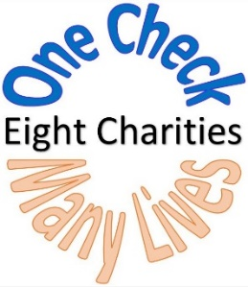

PLEASE PRINT LEGIBLY OR TYPE

Name as to be listed in Tour Guide: ____________________________________________________________________________

Contact Name (if different)______________________________________________________________________________________

Mailing Address:_____________________________________________________________________________________________________________
(Tickets will be sent via mail.)

City/State/Zip:______________________________________________________________________________________________________

Email:_____________________________________________________________Phone#: _________________________________________
(Invoice and IRS donation letters will be sent via Email)

Please select Sponsor Level (circle one)

Bronze $ 250 - $ 499
Bronze Plus $ 500 - $ 999
Silver $ 1,000 - $ 1,499
Silver Plus $ 1,500 - $ 2,999
Gold $ 3,000 - $ 4,999
Diamond $ 5,000 - $ 9,999
Premier $10,000 -$14,999
Benefactor $15,000 or above
Other Please designate

Total Amount Contributed: $___________________Check if Club (See guideline below.):_____

Payment Information (check one)
________Check Enclosed _______Please Send Invoice
________Credit Card (please go to www.smlcharityhometour.com and click on “Donate Now.”)

Complementary Tickets: You will receive one ticket for every $500 donated.

Designate donation to specific Home or Charity: __________________________________________________________________
(If blank, donation will be designated to all charities.)

Club Guideline: If a club would like an ad in the Tour Guide, the size of the ad will be determined by their sponsorship level.

02/02/2021SM

