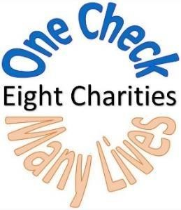

2020 SML Charity Home Tour
Sponsor Agreement

PLEASE PRINT LEGIBLY OR TYPE

Name: ________________________________________________________________________________________________________________________________________

Address:___________________________________________________________________________________________

Email:___________________________________________________________Phone#:___________________________
(All Invoices, receipts, and IRS letters will be sent via Email)

Signature:________________________________________________________Date:_____________________________

Amount Donated: $___________________

Payment Information: (check one)

_____Check Enclosed _____Please Send Invoice ______Credit Card (www.smlcharityhometour.com and click on “Donate Now.”)

Business Section:

Business Name:___________________________________________________________________________________________________________________________

Business Web Site: __________________________________________________________________________________________________________________________

Business Contact:____________________________________________Phone#:________________________Email:_______________________________________________
(If different from above.)

Business Benefits
- A one-time Charity Home Tour (CHT) ad in a local publication.
- Exposure on the SML CHT website for the remainder of 2020.
- Exposure on the SML CHT Facebook page for the remainder of 2020.
- Exposure though email blasts during 2020 to over 3,500 previous volunteers / ticket holders / homeowners.

Please return by August 1, 2020. SML Charity Home Tour, PO Box 416, Moneta VA 24121, or email to: Chtdata2015@gmail.com

