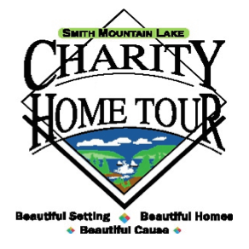

The Smith Mountain Lake Charity Home Tour Board would like to invite you to apply to become a selected charity in the 30th Charity Home Tour to be held Columbus Day weekend, October 9, 10, and 11th 2020. Proceeds of the Home Tour will be shared amongst the charities to promote your respective missions. Nearly $4 million has been distributed to over 40 charities since 1991!

The mission of the SML Charity Home Tour is to provide funds in support of local and regional charities through a united volunteer-driven community effort. This event generates a sense of community amongst those involved; our local charities, local business, volunteers and many others who have contributed to our success over the years.

The Board works with your key volunteer team through workshops and other activities, to ensure all key volunteers and therefore the Tour, are successful.

Smaller charities may apply as one unit, combining their volunteers and splitting the proceeds as explained in the Charity Application Protocols on the website.

To learn more about the event and to complete the application, visit our Website home page www.smlcharityhometour.com. Simply click on Charities at the top of the website home page to review and complete the following:

1. Charity Application Protocols
2. Charity Application
3. Participation Agreement
4. Key Volunteer Roles and Responsibilities
5. DRAFT Key Volunteer Form

To be considered, please submit your application by October 31, 2019. If you have any questions, please do not hesitate to contact Cheryl Crouse, Charity Administrator, at 336-442-3839 or email at cqcrouse555@yahoo.com.

Thank you for your interest in partnering with us to support those in need in our area. The SML Charity Home Tour is an all-volunteer organization working with you to serve our community.

Warm Regards,

Cheryl Crouse,
Charity Administration Chair

