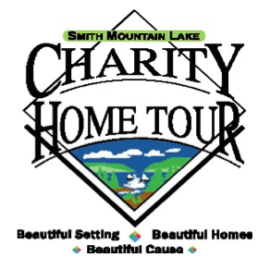

CHARITY APPLICATION PROTOCOLS

To be considered for the SML Charity Home Tour, the following criteria must be met:

- The charity must possess a 501(c) 3 tax-exempt status.

- The charity must provide services directly to the Smith Mountain Lake geographic area.

Note: Smaller charities may apply as one unit, combining their volunteers and splitting the proceeds. However, each charity will be required to complete the pre-requisite information individually, then combine and submit as one package.

- Each charity chosen must be prepared to supply 7 Key Volunteers as defined in the Key Volunteer job descriptions which you can find on the website.

- It is not necessary that these 7 Key Volunteers come directly from your employee or volunteer pools. It is necessary that the charity take responsibility for the identification, placement and commitment of those identified.

- No key volunteer should be assigned to more than one job due to the work commitment for each position.

- Your 7 Key Volunteers must have good organizational and communication skills.

- Your charity representative will be asked to attend a check distribution event in November and will be asked to inform those in attendance as to how the charity proceeds will be utilized.

- At the December kick-off event, each charity will be required to execute a Participation Agreement which you can find on the website.

If your charity is able to satisfy the above-referenced requirements, please fill out and submit the Application that you can find on the website. If mailed, three (3) copies of the information need to be submitted.

Revised 8/19/19 CC

