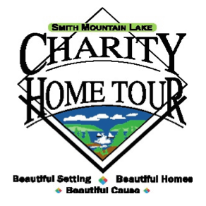

The Smith Mountain Lake Charity Home Tour Board would like to invite you to apply to become a selected charity in the 31st Charity Home Tour to be held Columbus Day weekend, October 7, 8, and 9th 2022. Proceeds of the Home Tour will be shared amongst the charities to promote your respective missions. Nearly $4 million has been distributed to over 46 charities since 1991!

The mission of the SML Charity Home Tour is to provide funds in support of local and regional charities through a united volunteer-driven community effort. This event generates a sense of community amongst those involved; our regional charities, local business leaders, volunteers, and many others who have contributed to our success over the years.

The Board works with your Key Volunteer Team through workshops and other activities to ensure a successful experience for all.

Smaller charities may apply as one unit, combining their volunteers and splitting the proceeds as explained in the Charity Application Protocols on the website.

1. Charity Application Protocols
2. Charity Application
3. Participation Agreement
4. Key Volunteer Roles and Responsibilities
5. Key Volunteer Form

To be considered, please submit your application by Monday, November 22, 2021. If you have any questions, please do not hesitate to contact Marci Waro, Charity Administrator, at 571-220-9289 or email at charitysmlcht@yahoo.com.

Thank you for your interest in partnering with us to support those in need in our area. The SML Charity Home Tour is an all-volunteer organization working with you to serve our community.

Warm Regards,

Marci Waro
Charity Administration Chair

