 | Mail this contract with payment to:  SML Charity Home Tour, PO Box 416, Moneta VA 24121  Or email to: Chtdata2015@gmail.com (pay separately) | 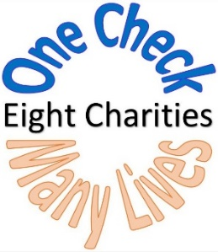
2019 Individual/Charity Patrons/Clubs
Sponsor Contract

This form is for Individual/Charity Patrons and Clubs.

PLEASE PRINT LEGIBLY OR TYPE

Name as to be listed in Tour Guide: _______________________________________________________________________________________________

Contact Name (if different):_______________________________________________________________________________________________________

Mailing Address:______________________________________________________________________________________________________________________
(Tickets will be sent via mail.)

City/State/Zip:________________________________________________________________________________________________________________________

Email:_______________________________________________________________________________Phone#: _________________________________________
(Invoice and IRS donation letters will be sent via Email)

Please select Sponsor Level (circle one)

Bronze $ 250 - $ 999
Silver $ 1,000 - $ 2.999 (2 comp tickets)
Gold $ 3,000 - $ 4,999 (4 comp tickets)
Diamond $ 5,000 - $ 9,999 (6 comp tickets)
Premier $10,000 -$14,999 (8 comp tickets)
Benefactor $15,000 or above (10 comp tickets)
Other Please designate

Total Amount Contributed: $___________________Check if Club (See guideline below.):_____

Payment Information (check one)
________Check Enclosed _______Please Send Invoice
________Credit Card (please go to www.smlcharityhometour.com and click on “Donate Now.”)

Designate donation to specific Home or Charity: ________________________________________________________________________________
(If blank, donation will be designated to all charities.)

Club Guideline: If a club would like an ad in the Tour Guide, the size of the ad will be determined by their sponsorship level.

1/15/19SM

